

B

 |  | Bosmere Bulletin
 |  | 2026-27 |  |  |  |  |  |  |  | Issue 4

I’m really glad that Mrs. Carr and I have been getting to know so many of our Bosmere parents. We would welcome you to approach us, if you feel you have some feedback to raise. One such piece of feedback was regarding reflections. As you will know, our behaviour policy has a system of reflections at lunchtime- essentially a time for the child to talk through what has happened and how we move on from it. Parents fed back that it was taking too long to hear about their child being given a reflection slip. Please feel that you can approach your child’s teacher about reflections, and they will be informing you if your child is being given a consequence more frequently.
Just another reminder, that I would like to share with you that Monday Munch has started. Run during term-time from 8:40-9:30 in the Robins Family Hub, it is an opportunity for parents to chat, make friends and have refreshments. Ideal if you are new to the area.
We have had a fabulous week of learning this week and I always try and find something that has been a particular highlight. I have really enjoyed some of the practical maths activities going on in Year 1 and 2. Using the break-out space outside of each classroom, the classes have been able to reinforce their learning in practical ways, using concrete resources to consolidate their learning.
Classroom Champions:
Elm- Magnus
Oak- Jesse G
Fern- Finley
Cherry- Marnie
Apple- Mollie
Beech- Emily W
Holly- Olivia B and Gia
Alder- Lewin
Hazel- Ernie

Events

8.10.26 YR parent session 2:30
9.10.26 2:30 9th Y1/2 phonics activities and phonics check info session
14.10.26 Parents Evening
23.10.26 Harvest Festival
6.11.26 2:30 Y6 parent assembly
13.11.25 2:30 Y5 parent assembly
20.11.25 Y4 parent assembly
20.11.26 4:30-5:30 EYFS bedtime read
27.11.26 2:30Y3 parent assembly
4.12.26 2:30 Y1/2 parent assembly

Nursery/ Reception Nativity: 16th Dec and 17th Dec

22.1.27 Y6 SATS Meeting
5.3.27 World Book Day
2.3.27 YR parent session 2:30
17.3.27 Parents Evenings
16.4.27 2:30 Y1+2 Phonics activities and information
11.6.27 Sports Day
18.7.27 Sports Day back up
16.7.27 5pm Y5/ 6 play
20.7.27 2:30 Y6 assembly
 |  |  |  | Step out with purpose this September and take part in the Home-Start Hike!  On Sunday 27th September, the Home-Start Hike is taking place at Kingfisher Leisure Centre, Sudbury, raising money to ensure Home-Start Suffolk can continue providing critical support to families of all kinds that are struggling in silence behind closed doors.  This year’s 3-mile route includes a fun family challenge, with a prize for every child and a very special guest – Bluey the dog!  There are also 6 or 13-mile scenic routes in the Suffolk countryside that you can take part in if you would like to walk further.  Whatever inspires you to take part, your steps will help support a great local cause.  You can find out more about the Home-Start Hike at: https://homestartinsuffolk.org/home-start-hike-2026/
 |  |  |  | Assembly Themes  This week, our assemblies have mainly focused on our school value of respect. There has been great excitement as the children start to see the house points tally up.
In the Community
 |  |  |  |  | If you have something that you would like to share or celebrate then please let us know by emailing admin@bosmereprimary.net and we will add it to the next issue! |  |  |  | 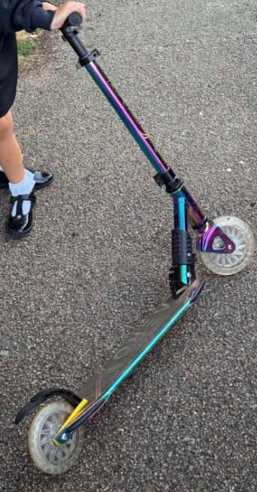  Please can you keep an eye out for this scooter that has gone missing from the school. If you see it, please can it be returned to the school.
Thank you for your continued support. If you have any concerns, do talk to your child’s class teacher in the first instance and if they cannot resolve the matter then a member of the leadership team will support.

Thank you for your continued support

The Bosmere Leadership Team

