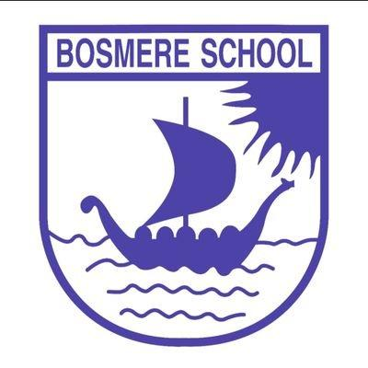

B

 |  | Bosmere Bulletin
 |  | 2026-27 |  |  |  |  |  |  |  | Issue 6

Another week flies by and we are already only a few weeks from half term. The heat wave seems a distant memory, so please can we insure children have waterproof coats with them? We would like to have children enjoying their breaks and lunchtimes outdoors as much as possible.
There’s been an exciting addition to our dates for the diary below. I have met with representatives of the PFA and agreed to some wonderful events throughout the year, starting with the return of a disco. Keep an eye out for further information and for communication of the other events.
This week, I wanted to highlight some of the excellent real-world maths that was completed in Apple Class recently. Several of the classes took part in the ‘Money Matters’ CUSP Festival aimed at improving financial literacy. In a world where our money becomes more and more contactless, it was a fantastic way of exploring the real value of coins.
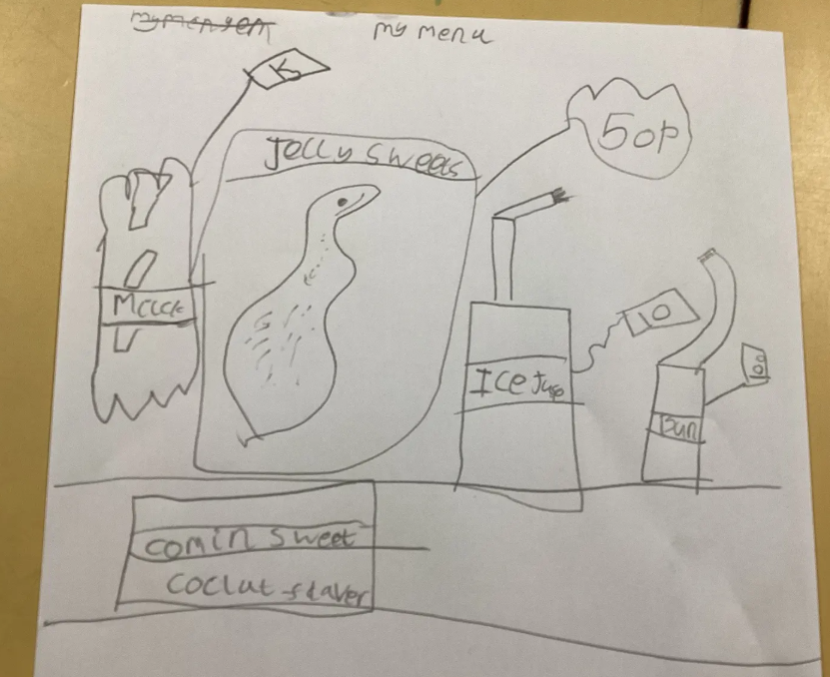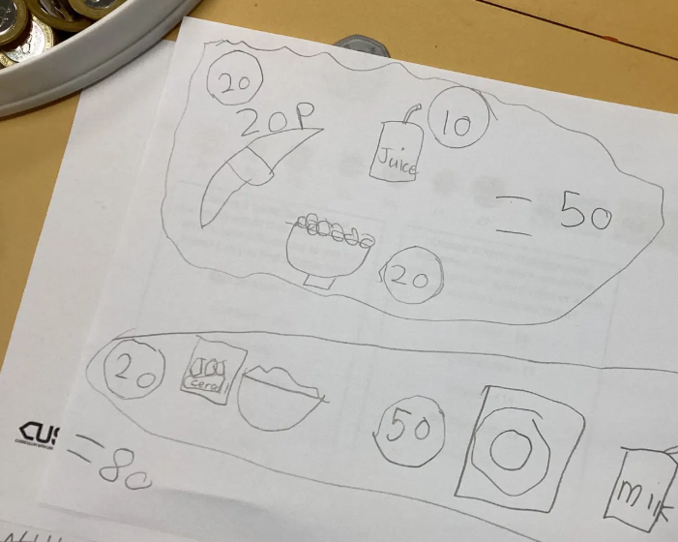


Saplings- Eden
Elm- Rexy
Oak- Finley
Fern- Bealia
Cherry- Jesse
Apple- Ammy
Beech- Jess
Holly- Olivia J
Alder- Alfie
Hazel- Harvey

Events

14.10.26 Parents Evening
16.10.26 2:30 9th Y1/2 phonics activities and phonics check info session REARRANGED
23.10.26 Harvest Festival
6.11.26 2:30 Y6 parent assembly
13.11.25 2:30 Y5 parent assembly
20.11.25 Y4 parent assembly
20.11.26 4:30-5:30 EYFS bedtime read
26.11.26 PTA disco
27.11.26 2:30 Y3 parent assembly
4.12.26 2:30 Y1/2 parent assembly
8.12.26 Autumn Rocksteady performance

Nursery/ Reception Nativity: 16th Dec and 17th Dec

22.1.27 Y6 SATS Meeting
5.3.27 World Book Day
2.3.27 YR parent session 2:30
9.3.27 Spring Rocksteady performance
17.3.27 Parents Evenings
16.4.27 2:30 Y1+2 Phonics activities and information
11.6.27 Sports Day
13.7.27 Summer Rocksteady performance
18.7.27 Sports Day back up
16.7.27 5pm Y5/ 6 play
20.7.27 2:30 Y6 assembly
Reception Open Days
Wednesday 4th November 9.30- 10.30
Monday 14th December 2.30-3.25
Wednesday January 6th 9.30-10.30

The PFA ran a summer bingo challenge which was a great success!  The winner of the summer bingo challenge was Ayla I from Cherry class who wins a goody bag of crafts! Well done!  The 5 Runners up that will receive a bag of Haribo sweets are :  1. Teddy- Alder class  2. Rowan- Cherry class  3. Hunter- Hazel class  4. Magnus- Oak Class  5. Bejinariu- Cherry class |  |  |  |  |  |  |  |  |  | Bosmere PFA News
 |  |  |  | Assembly Themes  This week, our assemblies have mainly focused on our school value of respect. We played particular attention to the similarities and differences in children’s lives and routines across the world.
In the Community
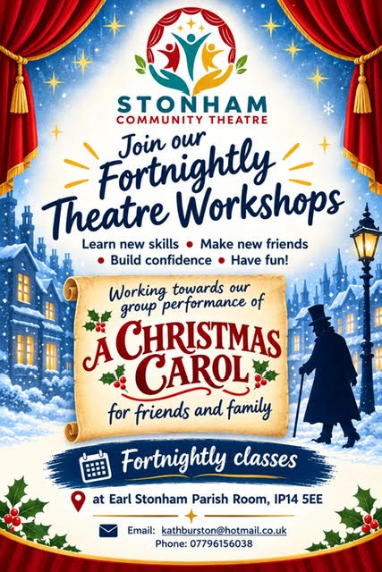 |  |  |  |  | If you have something that you would like to share or celebrate then please let us know by emailing admin@bosmereprimary.net and we will add it to the next issue! |  |  |  | 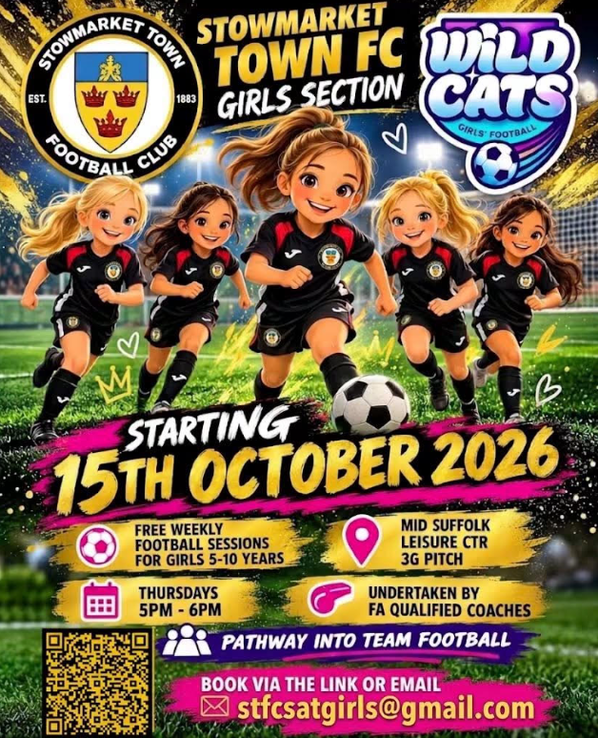
Thank you for your continued support. If you have any concerns, do talk to your child’s class teacher in the first instance and if they cannot resolve the matter then a member of the leadership team will support.

Thank you for your continued support

The Bosmere Leadership Team

