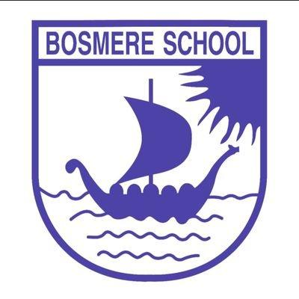


 |  | Bosmere Bulletin
 |  | 2026-27 |  |  |  |  |  |  |  | Issue 7

One more week to go until half term- this half term has flown by!
Please accept my apologies that the Bulletins have been coming out after the weekend. I’m sure you will appreciate that with how busy we have been it has been hard to meet that Friday deadline. For that reason, please expect Bulletin’s to be distributed, where possible, on a Monday.
As always, I have been popping into lessons throughout the week. On Wednesday, I had the pleasure of walking one of our governors around the school focusing our attention on behaviour and maths. It was a joy to see so many respectful children enjoying their maths lessons. This year, we introduced Power Maths as our maths scheme, which seems to have already had a positive impact on maths teaching. Children in Key Stage one in particular said ‘We love maths!’.
We continue to focus heavily on our ‘Respect’ value. I have had feedback from several parents that the conduct of some of our children outside of school has not been up to the high standards we expect with issues of swearing, anti-social behaviour and even racist words being used. If your child plays out on their own after school, please could you remind them of the behaviour we expect? We will do the same.
I look forward to seeing many of you on Friday for the Harvest Festival at St John’s Church.


Saplings- Scarlett
Elm- Toby
Oak- Opal
Fern- Arabella
Cherry- Rafe
Apple- Gracie
Beech- Isaac
Holly- Logan B
Alder- Emily A
Hazel- Ronnie

Events

23.10.26 Harvest Festival
6.11.26 2:30 Y6 parent assembly
13.11.25 2:30 Y5 parent assembly
20.11.25 Y4 parent assembly
20.11.26 4:30-5:30 EYFS bedtime read
26.11.26 PTA disco
27.11.26 2:30 Y3 parent assembly
4.12.26 2:30 Y1/2 parent assembly
8.12.26 Autumn Rocksteady performance

Nursery/ Reception Nativity: 16th Dec and 17th Dec

22.1.27 Y6 SATS Meeting
5.3.27 World Book Day
2.3.27 YR parent session 2:30
9.3.27 Spring Rocksteady performance
17.3.27 Parents Evenings
16.4.27 2:30 Y1+2 Phonics activities and information
11.6.27 Sports Day
13.7.27 Summer Rocksteady performance
18.7.27 Sports Day back up
16.7.27 5pm Y5/ 6 play
20.7.27 2:30 Y6 assembly
 |  |  |  | Dear Parents and Guardians,  We have a great opportunity for female students in Year 3–6 and Year 7-11 to attend a free trial training session at our Bury St Edmunds Development Centre. If offered a place, players join our programme under a modest participation fee, which grants them the following benefits:  - Weekly training sessions delivered by UEFA-qualified coaches — educational, fun, and skill-focused  - Training alongside talented peers to push development  - Access to the club’s full development pathway  - Full NCFC training kit  - Opportunities to travel on residential training retreats  - Competitive fixtures against other development programmes and local clubs  Training schedule:  Suffolk - Bury St Edmunds Girls Development Centre  Address: Bury St Edmunds Leisure Centre, Beetons Way, Bury Saint Edmunds IP33 3TT  Date: Friday 23rd of October 2026  Time: 6:00 - 7:30 pm or 7:30 - 9:00 pm  Age group: U9 - U12's (Year 4 - Year 7) or U13 - U16's (Year 8 - Year 11)  Outfield centre only  We also have a centre at Whitton in the heart of Ipswich. If you are interested in this session, please do let me know.  If your daughter would like to attend a free trial session, please sign up via our trial form or please contact me at Phil.turner@canaries.co.uk to arrange a free trial session.  Sign-up trial link: https://forms.gle/n6Wu5f1RskpVgD3q6  We look forward to welcoming any new players to the centre!  Kind regards,  Phil Turner  Norwich City FC  Head of Girls Football
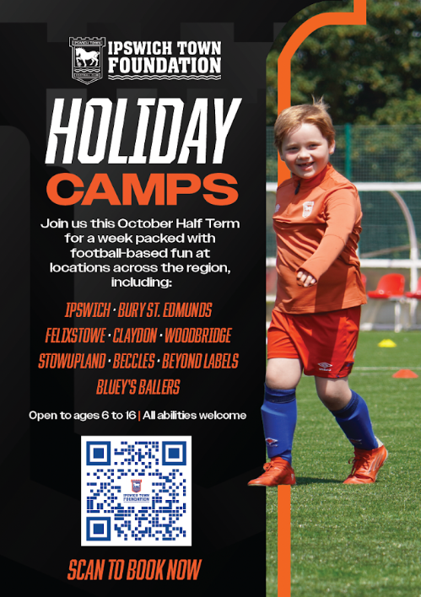 |  |  |  |  |  |  |  |  |  | 
 |  |  |  |  |  |  |  |  |  | Bosmere PFA News  On the 23rd October, the PFA are holding a bake sale. Please could all donations be brought to the school office on the morning of the 23rd. There will also be a second hand uniform sale at the same time.
In the Community
 |  |  |  |  | If you have something that you would like to share or celebrate then please let us know by emailing admin@bosmereprimary.net and we will add it to the next issue! |  |  |  | 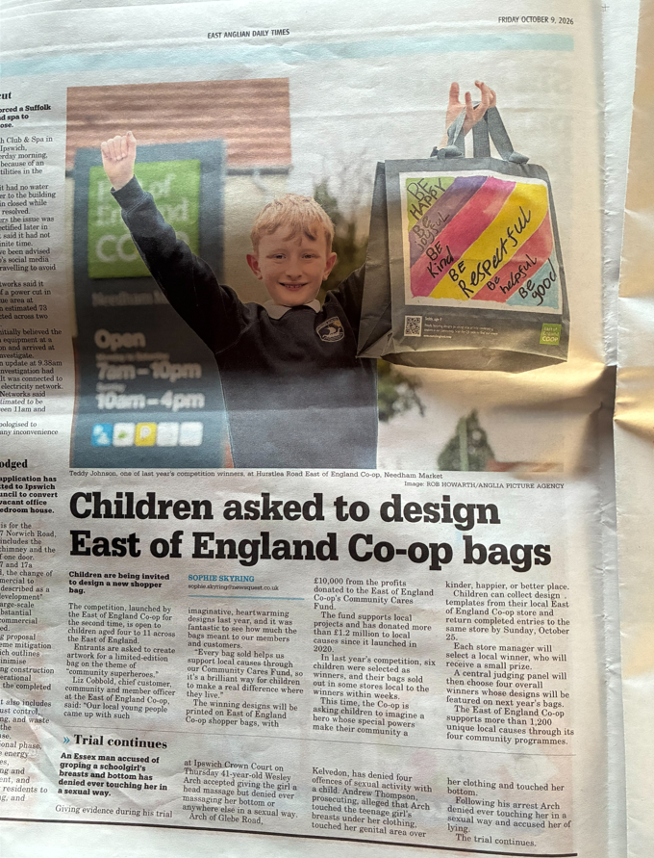  Well done Teddy, who made his way into the local newspaper after winning a competition to design a bag for the Co-op last year. Teddy is the face of this year’s competition- if any children would like to join the competition this year, then head down to the Co-op.
Thank you for your continued support. If you have any concerns, do talk to your child’s class teacher in the first instance and if they cannot resolve the matter then a member of the leadership team will support.

Thank you for your continued support

The Bosmere Leadership Team

