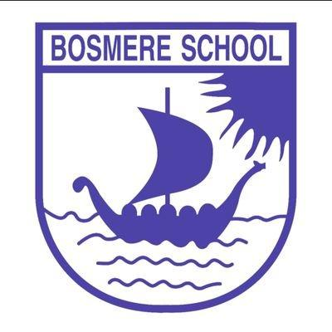


 | Bosmere Bulletin
 | 2026-27 |  |  |  |  | Issue 3

Firstly, apologies for the delay in this bulletin- it has been an incredibly busy few days! Another amazing week passed and it has seen the weather change and become quite unpredictable. With this in mind, please remind your children to bring a waterproof coat on days where rain is possible, to allow them to make full use of the outdoors at break and lunch.

I have very much enjoyed spending time in our Year 5 and 6 classes over the last week. They have been learning about subtractive art, inspired by artist Frank Auerbach. I was pleasantly surprised to see the budding artists in both classes- particularly those in Hazel class that produced some amazing pictures of mountains.

In order to ensure that there are no arguments in class, fairness and breakages, please can parents ensure that children do not bring any toys, cards, fidgets etc into school. If your child is one that you think may need a concentration aid, this will need to be approved by Mrs Thorpe and a school one will be provided.
I am delighted to share the arrangements for our Harvest Festival celebration this year. Our Harvest Festival will take place at Needham Market Church on Friday 23 October. The service will be led by Reverend Tracey, and we are looking forward to coming together as a school community to celebrate.
Many of you will have seen in the media that there have been updates to government policies that are in the pipeline for next year regarding healthy school lunches. To bring us in line with current and future guidance, the decision has been made to stop tuck for Year 5 and 6. Children will need to break in fruit or vegetables, as they would on non-tuck days.
As a result of feedback from parents, I ask that please can parents refrain from taking photos on the school playground during the start and end of the day.
Lastly, I would like to share with you that Monday Munch has started. Run during term-time from 8:40-9:30 in the Robins Family Hub, it is an opportunity for parents to chat, make friends and have refreshments. Ideal if you are new to the area.
Classroom Champions:
Elm- Orlaith A
Oak- Theo B
Fern- Freddie
Cherry-Owen
Apple- Margot
Beech- Kingsley
Holly- Gia
Alder- Daisy
Hazel- Charlie

Events

25.9.26 YR parent session 2:30
8.10.26 YR parent session 2:30
9.10.26 2:30 9th Y1/2 phonics activities and phonics check info session
14.10.26 Parents Evening
23.10.26 Harvest Festival
6.11.26 2:30 Y6 parent assembly
13.11.25 2:30 Y5 parent assembly
20.11.25 Y4 parent assembly
20.11.26 4:30-5:30 EYFS bedtime read
27.11.26 2:30Y3 parent assembly
4.12.26 2:30 Y1/2 parent assembly

Nursery/ Reception Nativity: 16th Dec and 17th Dec

22.1.27 Y6 SATS Meeting
5.3.27 World Book Day
2.3.27 YR parent session 2:30
17.3.27 Parents Evenings
16.4.27 2:30 Y1+2 Phonics activities and information
11.6.27 Sports Day
18.7.27 Sports Day back up
16.7.27 5pm Y5/ 6 play
20.7.27 2:30 Y6 assembly
 |  | Step out with purpose this September and take part in the Home-Start Hike!  On Sunday 27th September, the Home-Start Hike is taking place at Kingfisher Leisure Centre, Sudbury, raising money to ensure Home-Start Suffolk can continue providing critical support to families of all kinds that are struggling in silence behind closed doors.  This year’s 3-mile route includes a fun family challenge, with a prize for every child and a very special guest – Bluey the dog!  There are also 6 or 13-mile scenic routes in the Suffolk countryside that you can take part in if you would like to walk further.  Whatever inspires you to take part, your steps will help support a great local cause.  You can find out more about the Home-Start Hike at: https://homestartinsuffolk.org/home-start-hike-2026/
Kittle has been booked to come into school on 25th September for school photos. Please ensure that children are in full school uniform, as they would be any other day. The uniform guidelines can be found on our website for clarification. |  |  |  |  |  | School Photos
 |  | Assembly Themes  This week, our assemblies have mainly focused on our school value of respect. This included singing a song that celebrates diversity and the fact that we are all unique.
In the Community
Well done to Teddy in Alder class, who last year came 2nd in top scorer and was runner up in the Plate Cup. He even got to play on the Portman Road pitch!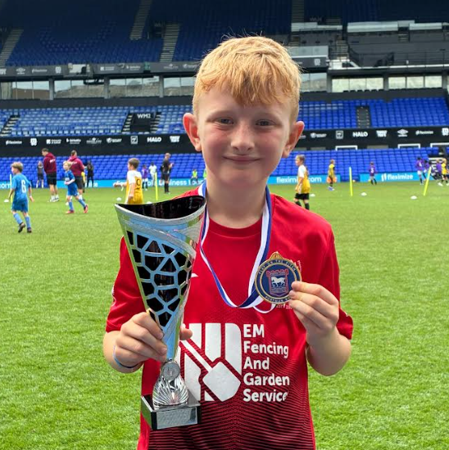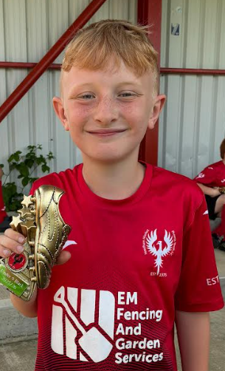 |  |  | If you have something that you would like to share or celebrate then please let us know by emailing admin@bosmereprimary.net and we will add it to the next issue! |  | 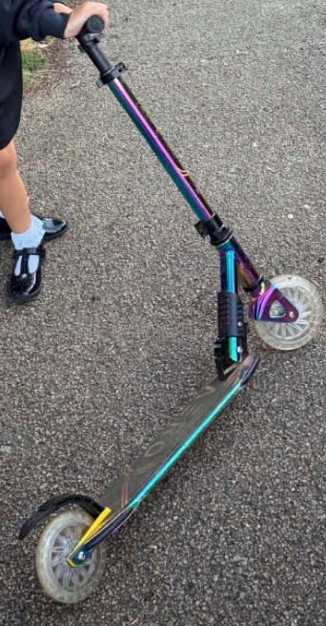  Please can you keep an eye out for this scooter that gone missing from the school. If you see it, please can it be returned to the school.
Happy Weekend!
Thank you for your continued support. If you have any concerns, do talk to your child’s class teacher in the first instance and if they cannot resolve the matter then a member of the leadership team will support.

Thank you for your continued support

The Bosmere Leadership Team

